Protoype Design for a Student Club Mobile App

Nelson Shaw
Department of Applied Computer Science
Sheridan College
Oakville, Canada
shawne@sheridancollege.ca

Victor Batirow
Deparment of Applied Computer Science
Sheridan College
Oakville, Canada
batirow@gmail.com
Muhammad Sabeeh Shah
Faculty of Applied Science & Technology
Sheridan College
Oakville, Canada
shahsabe@sheridancollege.ca

Abstract—The focus of this paper is the explore the prototype design process for the Clubber application, an application that is designed to support the college club market. The college club market has a need for a better process for stating up a club and managing clubs without having to use paper materials or a desktop application. The people in the college club market itself are looking for a way to sign up for clubs on a mobile app, hear about notifications for events, and be able to start a new club on a mobile device. Therefore, the Clubber mobile application was designed to allow students and administrators to join clubs, start a new club, create and schedule events, and to manage clubs within a college campus. We introduce the need finding process for the market, the initial prototype design, a second prototype design based on common HCI principles, results for users testing the second prototype, and a revised prototype based on the feedback of the users.
Keywords—HCI, Colleges, Clubs, Prototype,

Introduction
For any organization, college, institution, or even a group of people, they have their own way of managing clubs. One of the major real-world problems with organizing clubs is how to manage clubs more effectively and how to get students engaged in signing up for clubs and communicating with other students.
There are some existing apps that deal with this problem. One such app is called BAND – An App for All Groups [1]. BAND provides the functionality to allow anyone to create a group and setup events [1]. Additionally, there is also Gant – Groups and Teams, which also provides a similar service to BAND, only with not as much attention to the user interface design [2]. Finally, the North West College and the Lakeland College applications are similar to each other in that they provide services for students to join a club and an event taking place at the campus [3] [4] [5]. However, both the North West College app and the Lakeland College app do not provide the student with the ability to start new clubs [3] [4] [5].
The focus of this paper will be on our club management mobile app design. Our mobile app is called Clubber. Clubber is a stand-alone mobile application utilized by students and student unions in order to create and manage student clubs. The purpose of the application is to allow students and student union members to organize clubs. The app will display the name of the club, the location, and the times that the club will be active during a given week. The students will have the ability to select from various clubs and sign up for them with relative ease using the application. While it is not mandatory to connect to a network in order for students to receive news about club events and new clubs, connecting to a network allows the students to sign up for clubs, students to start new clubs, and club managers to organize and review club start-up forms, club event forms, and club visualization change forms. The application will be built on Android using ASP.net as a backend service. The audience for the app will be students, club leaders, and managers of clubs across all campuses at Sheridan.
In comparison to the North West College and Lakeland college applications, which do not provide functionality for managing all clubs at a campus, the Clubber app will also provide services to the Sheridan Student Union members by allowing them to manage all of the clubs at a particular campus and approve a club start-up process from a student [3] [4] [5]. Compared to BAND and Gant, the Clubber application will allow students to request promotional materials for their club from the management at the Sheridan Student Union through the app itself [1] [2]. Additionally, the application will consider HCI principles that are important for the student audience and management audience at the Sheridan college campus, as some of the existing solutions contain user experience design issues that our application will improve upon. The paper will first discuss some of the HCI principles considered while developing our application prototype in section II. Section III will focus on the prototype design of the Clubber application with regards to the need finding process, analysis of competitor apps, and prototype alternative analysis. Section IV discusses the prototype evaluation process. Section V will discuss the usability analysis of the prototype based on the feedback provided by two users of the prototype. Finally, section VI will look into the revised prototype.

HCI Principles
The Clubber application considered 3 major HCI principles in mind while designing the initial prototype.

Mobility and Providing Information from the Internet.

Personalized Notifications.

Content Control.

One design aspect that needed to be considered for our application was the use of mobility and being able to provide information that was provided from the internet to the students. Essentially, Said and Refaat conducted a study about students interacting with a mobile student portal application [6]. Said and Refaat explain that “the frustration from loading photos and videos included in the mobile portal in public areas within and outside campus, with unreliable and low-speed Internet connectivity, was cited as the main reason for not using the mobile portal” [6]. Additionally, Said and Refaat explain, “Offline features can deal with this issue by giving users the option to download videos and large pictures beforehand with a reliable Internet coverage, to watch them later when they move to a nonreliable coverage” [6]. Because the application is a stand-alone mobile application that requires information from the internet, a design concept that needs to be taken into consideration is the mobility of the application for students and being able to utilize the application and its features anywhere. The student should know what features will be available to them and know why they will not be able to access certain features of the application. Because students are off campus a lot, they would need to access to some of these features offline.

Second, another design aspect that needs to be taken into consideration for students for our application was the use of personalized notifications. Said and Refaat show, “Some interviewees showed preference that the mobile student portal provides personalized notification based on student’s academic status and relevant deadlines” [6]. Additionally, as explained by Said and Refaat, “Examples of these personal notifications were given by the interviewees, as following: changes in the timetable of the student’s specific bus, warning for the student’s own absenteeism rate, deadline for registration and add and drop courses, and notification for events of the student’s faculty or class” [6]. Students would need to have personalized notifications especially for when they are signed up to clubs and they want to know about any club events that occur associated with their club. These personalized notifications for our app would be for club events that will take place soon.

Finally, another design aspect that needs to be taken into consideration for students for our application was the ability for students to control the content on the app. Said and Refaat explain that “many of the interviewees suggested a control over content, enabling the user to select between detailed versus brief text and text versus videos, for each content included in the mobile students’ portal” [6]. Students want to be able control over what information will be shown for them in our application. Essentially, for our app, brief information should be shown to the student about a club, such as its name and a promotional image. When the student wants more detailed information, they should have the ability to view that information when selecting the club on the home screen. We need to consider that these students want control over what information they are presented, especially considering the context of their degree program.

Prototype Design

Requirement Analysis (NeedFinding)
With regards to requirements analysis, we have taken into consideration with meeting with the management at the Sheridan Student Union in order to identify the real-world problems in the club management domain. We have initially identified 3 combinations of user groups and activities.

Students and Engaging with Clubs.

Club Leaders and Promoting Club Events.

Club Managers and Organizing Clubs.

We have decided to interview students and club leaders in the activity of engaging with a club in order to understand the domain. Before the interview process, we proposed 3 hypotheses about the group in question.

Most students hear about event notifications through desktop and through their peers than on mobile.

Students use desktop over mobile to look for clubs to sign up for.

Students use desktop over mobile to start up new clubs.

First, desk research was performed in order to understand the solutions which competitors have provided. These solutions include Clubs Corner, ClubRunner, and the previously mentioned North West College application [3] [7] [8]. Please note that these competitor apps were found before finding BAND, Gant, and Lakeland College [1] [2] [4] [5]. The Clubs Corner app was not considered in the competitor’s matrix because it was a website compared to a mobile application [7]. In addition, the ClubRunner app was not included in the matrix because it was not as related to the domain as other applications [8].

Clubs Corner is a web application that can be accessed on a desktop and on a mobile device [7]. Currently, the website does not provide any in-app notifications or the ability to submit requests about which clubs students want [7]. The user cannot start a new club on the mobile device version of the web application [7]. On desktop, students will be able to receive notifications of events through their Sheridan account [7]. Additionally, students using the desktop application will be able to start clubs using a waiver form online [7]. Students can sign up for clubs both on the mobile and desktop versions of the web application [7].

The other application that involves engaging with clubs is the ClubRunner application [8]. ClubRunner involves being able to engage in events rather than start-up clubs [8]. There does not appear to be any functionality to start new clubs [8]. The application appears to only provide the ability for users to attend and track events [8].

There is the also the North West College and Lakeland College Android App [3] [4] [5]. These applications allow for students to engage in clubs and groups at the college [3] [4] [5]. It also allows students to plan for events at the club [3] [4] [5]. However, the apps do not appear to allow users to start a new club [3] [4] [5].

The BAND and Gant applications are mobile applications that allows users to start a new club, start events, join clubs, and join events [1] [2]. However, the application does not allow users to request promotional materials and to identify highly requested clubs from students of a college [1] [2].

We found that students could start a club on the Clubs Corner website if they were on their desktop computer [7]. They could not start a new club on the website if they were using their mobile phone [7]. Additionally, there were paper forms that students could use to start a new club. Students could sign up for clubs on the Clubs Corner website on both desktop and mobile. [7] Students could also sign up for clubs by appearing at the club location.

Next, field research was performed in order to discover the latent needs of students and club leaders at Sheridan College. The method of gathering the latent needs of students was through the use of a survey. There had been 12 responses from our survey with all of them being students that are engaging in a club. One iteration of the survey was sent to a game club at Sheridan. Initially, the survey was designed to have an “Other” option in the event that students performed the given task in a different way. However, it was unclear how they performed the task. As a result, the survey was updated slightly to accommodate for other responses and the survey was presented to another club group at Sheridan. The survey contains 7 questions.

How did you hear about club events related or not related to your club?

How did you hear about the club(s) that you are currently in?

How did you sign up for your club(s)?

How would you rate your experience for the process of finding and signing up for the club?

Have you started a club before?

If so, how did you start the club?

How would you rate your experience for the process of starting the club?

One of our initial hypotheses was that students tend to hear about events from their peers and on desktop than on mobile devices. We asked students about how they heard of these events related or not related to their clubs. The results of this question can be found in Fig. 1. Keep in mind that in the first 3 questions, these responses were found through checkbox questions and not multiple choice to consider that the user may be a part of multiple clubs. The survey had shown that there were 6 of 12 responses where students had heard of these events from a friend. About 7 of 12 responses showed that students heard of these events while attending the club. Only 3 of 12 responses showed that these students heard of the events on the Clubs Corner desktop web application [7]. About 3 of 12 responses shows that students heard of these events from a computer email. About 3 of 12 responses shows that students heard of clubs from a poster. About 3 of 12 responses showed that students heard of these events from other sources such as a student union newsletter and being an executive who plans the events. Only 1 of 12 respondents heard of an event through a mobile device.

Therefore, our hypothesis was correct in that a lot of students tend to hear about events through their peers than on mobile. However, our hypothesis was slightly incorrect in that not a lot of respondents used their desktop computer to hear about events. We also found that a lot of students hear about club events while at the club.

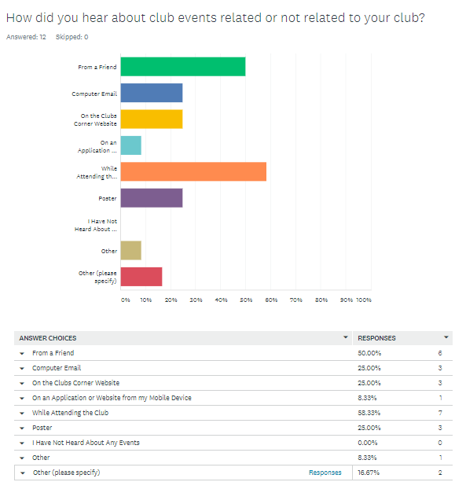
- How Students Heard About Events
Another hypothesis that we formulated was that students tend to use desktop over mobile to sign up for clubs. We asked students about how they heard about the clubs that they are currently in. The results of this question can be found in Fig. 2. About 2 of 12 respondents heard of the clubs through a poster. About 3 of 12 respondents heard of the clubs through the Clubs Corner website on their desktop [7]. About 5 of 12 respondents heard of the clubs from their friends. About 6 of 12 respondents heard about these clubs through other sources such as a club representative coming to the class or a club fair.

In another question, we asked students about how they signed up for the clubs that they joined. The results of this question can be found in Fig. 3. About 8 of 12 respondents joined their clubs by appearing at the club location. About 3 of 12 respondents joined their clubs by signing up at the Clubs Corner website on their desktop [7]. Only 1 of the 12 respondents signed up to their clubs through email. None of the respondents signed up using a mobile application. About 3 of 12 respondents joined the club by other methods.

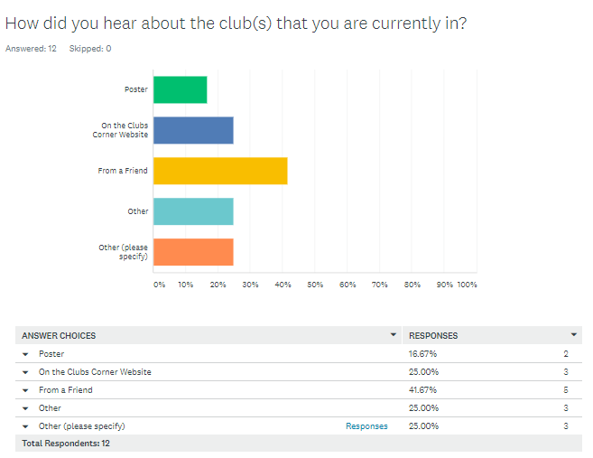
- How Students Heard About Their Clubs

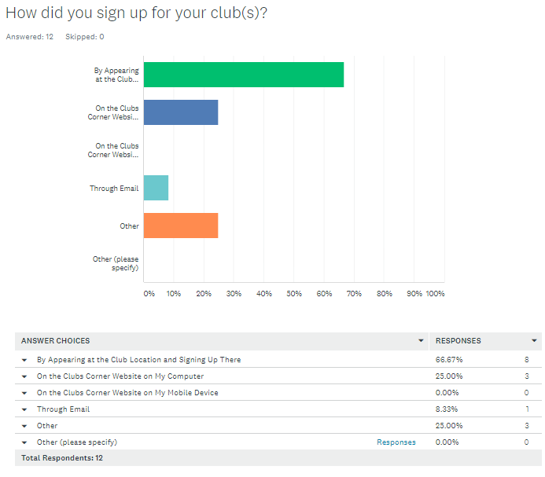
- How Students Signed Up for Their Clubs
We then asked students about their experience with signing up for clubs. The results of this question can be found in Fig. 4. About 3 of 12 respondents were very satisfied with signing up to their clubs. About 5 of 12 respondents were satisfied with signing up to their clubs. About 3 of 12 respondents were neither satisfied nor dissatisfied with signing up to their clubs. Only 1 of 12 respondents was very dissatisfied with signing up to their clubs.

Therefore, our hypothesis is incorrect in that most students sign up for clubs by appearing at the club. However, our hypothesis was slightly correct in that more students signed up for clubs on desktop than on mobile devices.

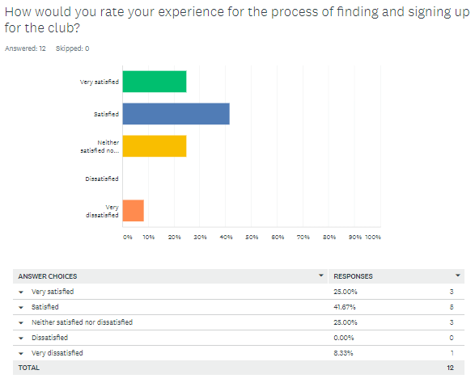
- How Students Rated Their Experience with Joining a Club
Finally, we had a hypothesis about how students use desktop over mobile devices to start a new club. We asked if the respondents had started a club before. The results of this question can be found in Fig. 5. Only 2 of 12 respondents had started a club.

We asked these respondents how they started the club. The results of this question can be found in Fig. 6. These 2 of 12 respondents started up the club through the use of paper forms. This information was also based on feedback from the individual responses, since some respondents provided a different response even though they answered that they never started a club before.

We then asked these respondents about their experience when starting the club. The results of this question can be found in Fig. 7. Based on the individual responses, the first respondent was satisfied while the second respondent was neither satisfied nor dissatisfied. The other responses were from students who have not started a club before.

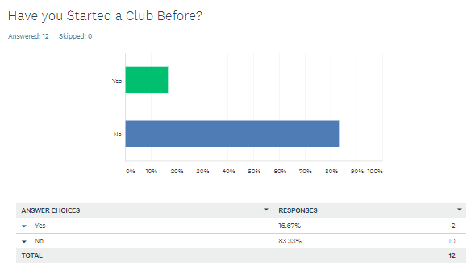
- How Many Students Started a Club

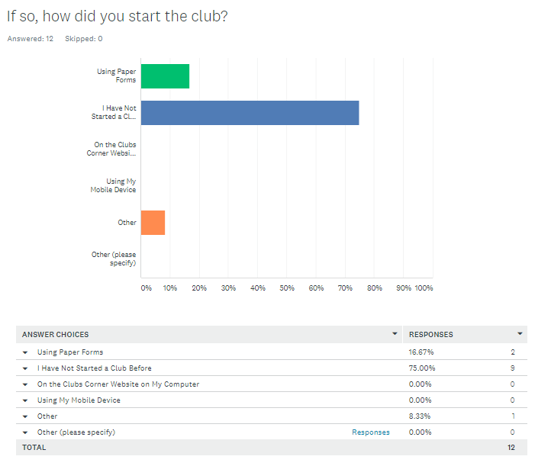
- How These Students Started Their Clubs

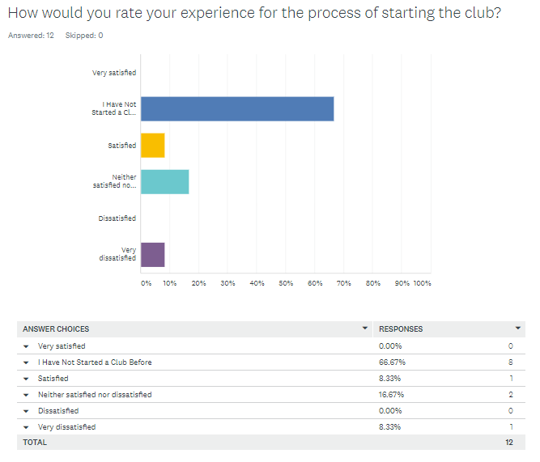
- How These Students Rated Their Experience with Starting a Club
Therefore, this hypothesis is incorrect in that students start clubs through paper forms. However, students also do not use their mobile devices to start up new clubs.

Based on the data which we have collected, we have found that one of the latent needs that students would require is a way to sign up for these clubs on a mobile device. Because most respondents signed up to the club by having to appear at the club and working with the Clubs Corner website, there is the workaround of signing up for a club by using the website or going to the club location [7]. Therefore, our product can allow the user to sign up for these clubs in a very convenient way compared to the Clubs Corner website on mobile [7]. Our mobile application will allow students to join a club anywhere without having to appear at the club location.

Another latent need that was identified was the need of hearing about club events in a better way. Currently, most students heard about these club events from a friend or while attending the club. However, only 1 respondent heard of events through a mobile application. Therefore, we can remove the workaround of having to hear from peers or having to appear at the club by providing a mobile application that will give them notifications of any upcoming events from clubs that they are currently signed up for. Based on existing solutions as well, there are currently no event notifications on the mobile version of the Clubs Corner website [7]. A major product opportunity would be to provide in-app notifications to students about upcoming club events for the clubs that they signed up for.

Finally, a latent need which we have identified was the need of starting a club. The respondents that started a club are currently using paper forms to start their clubs as a workaround. Therefore, one of our product opportunities is to remove this workaround and allow students to start clubs on a mobile device instead of on paper. The mobile application will allow students to fill out the information needed to start a club without having to write it on paper.

Competitive Analysis
A competitive analysis matrix was composed based on some of the competitors that were identified such as BAND, Gant, Lakeland College, and North West College [1] [2] [3] [4] [5]. The competitive analysis matrix features a total score for each application measured in percentage. Each feature mentioned are the features which the Clubber application will have. Table 1 demonstrates the competitor analysis matrix.
- Competitor Analysis Matrix
Features | Competitor Applications
Features | Score | Clubber (Our App) | BAND | Gant | Lakeland College | North West College
Search for  Specific  Clubs | 10 |   |   |   |   |     
Sign Up for Clubs | 10 |   |   |   |   |     
Search for Events | 8 |   |   |   |   |     
Start a New Club | 9 |   |   |   |   |  
Post  Discussion  Boards | 4 |   |   |   |   |     
Host Events | 8 |   |   |   |   |  
Provide  Promotional  Club  Materials (e.g.  Posters) | 4 |   |   |   |   |  
Manage  Club  Start up,  Event, and  Promotion  Forms | 7 |   |   |   |   |  
Receiving Feedback from  Members about Highly  Requested Clubs | 4 |   |   |   |   |  
View Club Logistics such as Number of Members and Events  Held | 3 |   |   |   |   |  
Option to  Receive  Notification of Club Posts | 7 |   |   |   |   |     
Total Score | 74/74 =  100% | 74/74 =  100% | 59/74 =  79.7% | 59/74 =  79.7% | 42/74 =  56.8% | 39/74 =  52.7%

First Initial Prototype Alternatives
The first prototype designs for the Clubber application can be found within a link provided. Each member of the team worked on an individual prototype [9] [10] [11] [12].
Fig. 8. demonstrates an initial home screen for the user. This home screen was more focused on allowing the user to find a club [9] [10].
Fig. 9. demonstrates the same home screen for another initial prototype [9] [11].
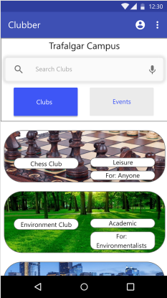
- Prototype #1 Home Page [9] [10]
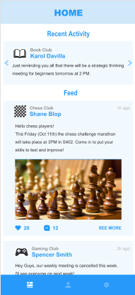
- Prototype #2 Home Screen [9] [11]
Fig. 10. demonstrates the third home screen for the initial prototype [9] [12].
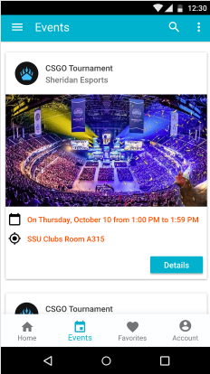
- Prototype #3 Home Screen [9] [12]
In addition, the third prototype also has a club start-up screen which is shown in Fig. 11. [9] [12].
There are some radical differences in the 3 initial prototypes. One of the home screens focuses on providing a list of clubs to students [9] [10]. Another focuses on posts and events [9] [12]. Finally, one focuses on strictly posts [9] [11]. The visual design of each prototype is also different.
As a team, we have developed an improved prototype based on some HCI principles. First, we discussed the important principle of color. Color can be used not only to be aesthetically pleasing to the user with analogous colors, but also by bringing attention to certain items. A work performed by Xiaoxiao and Wenming [13] demonstrates how effective color design is needed for a mobile application [13]. Xiaoxiao and Wenming show how “it is not only possible to simply stay in the color and aesthetic point of view to design, but to more deeply combine the relationship between color and the product itself and the experience it brings to the user” [13]. Additionally, Xiaoxiao and Wenming show, “All these visual information that users want to understand and designers want to convey is the most important manifestation of functionality in color design” [13]. A small visual shortcoming of one of the initial prototypes is the grey color of the text that shows what hour the post was made or last updated [9] [11]. The text is difficult to see because of the lack of color contrast with the background [9] [11]. Additionally, in the prototype shown in Fig. 11., there is an inconsistency of color usage, especially for the buttons [9] [12]. A dark color is used for the text of the buttons but a white color is used for the title of the screen [9] [12]. The color of the text should remain consistent when using a blue background behind the text. As a result, there was an effort to ensure that there was color consistency with the application not only to make it aesthetically pleasing, but to also ensure that certain actions are expressed and visible to the user so that they are brought to their attention faster [13]. Fig. 12. demonstrates a screen from the second prototype featuring an updated color scheme [9] [14]. Compared to the first prototype, this features color consistency between buttons [9] [14]. Additionally, the color contrast of the buttons provides a visible action for the user [9] [14].
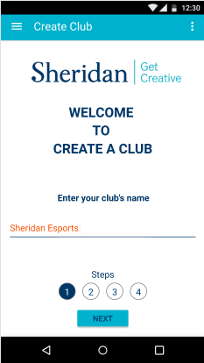
- Prototype #3 Club Start-Up Screen [9] [12]

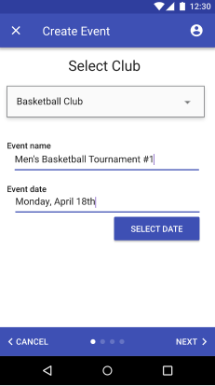
- Event Creation Screen with Color Consistency [9] [14]

Another paper written by Amer and Johnson [15] shows how the HCI principle of visualizing progress towards a particular goal can help the user become engaged with the application [15]. Amer and Johnson explain, “The purpose of progress indicators is to inform the user of the progress that is being made as the task moves toward completion” [15]. Before, a UX design issue that was identified in one of the initial prototypes is the lack of a completion meter when going through a series of steps [9] [10]. The user will be unsure about how far they are when they are accomplishing their goal if there is no completion meter [15]. Especially considering that the user will be going through a series of steps when accomplishing certain tasks such as creating a club or starting a new event, having a progress bar will help to show the user their progress and stay engaged with the application [15]. While this was present on one of the prototypes, it was critical to have on the second prototype [9] [12]. Fig. 13. demonstrates the second prototype with a screen showing the step-by-step process of signing up [9] [14].

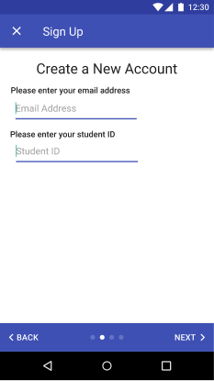
- Sign Up Screen with Progress Bar [9] [14]

Finally, the principle of recognition and recall was employed in the second prototype using icons and iconography [9] [14]. Iconography is important because not only does it allow the user to read the action of a particular button on a page easier, but also to reduce the memory load of the user. In a paper written by Isherwood, McDougall, and Curry [16], they demonstrate that icons can be significant for reducing the user’s memory load [16]. Isherwood, McDougall, and Curry explain that icon “familiarity is regarded as an index of ease of access to long-term memory representations” [16]. If icons are not used correctly, the can potentially lead to confusion when attempting to access a certain functionality in an application [16]. Fig. 14. demonstrates an updated home screen with updated iconography [9] [14]. The interface in the second prototype allows the user to clearly understand the actions of the software without having to remember explicitly [9] [14].
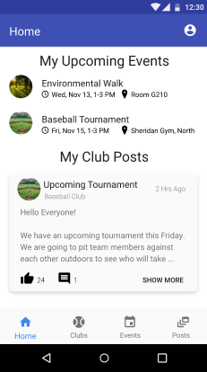
- Prototype Home Screen with Improved Iconography [9] [14]

Prototype evaluation
In order to evaluate our final prototype, we have published the prototype through UserTesting.com and asked 2 users to test the prototype [9] [14]. There were eight scenarios tested for the user. For each scenario, the user had to rate their satisfaction out of 5 and ask if they have completed the task successfully. The scenario for the Clubber test is as follows.

“You are using the Clubber application, an app that allows you, as a student, to join clubs, add events to your calendar, start a new club, start a new event, and create posts in clubs. As a club coordinator/administrator, you will be able to approve club start-up forms, event forms, promotional material forms, change the tier/level of a club, and provide announcements to students. Imagine that as a student, you want to use the app to join a club, an event, start a new club, start a new event, and provide a post in your newly created club. Imagine that as a club coordinator/administrator, you want to approve a club start-up form, change the tier of a club, and post a new announcement for students to read.”

The tasks for the test are as follows.

Log-in and Join the Baseball Club.

Add the Baseball Tournament Event to Your Calendar.

Start a Basketball Club.

Start a Basketball Tournament Event.

Create a Generic Post.

Log Out and Log-in as an Administrator and Approve or Deny the Chess Club Start-Up Form.

Change the Baseball Club to a Tier 3 Club.

Create a Generic Announcement.

After each task, the user was required to complete the following questions.

Did you complete the task successfully?

Overall, this task was: [Rating scale out of 5].

For the first question that was asked, “Did you complete the task successfully?”, there were 7 different responses from the user to choose from.

Yes, I’m sure I completed the entire task successfully.

No, I’m not sure if I completed the entire task successfully.

No, the task took too long that I gave up.

No, the site’s information or navigation was poor.

No, I encountered an error or a bug.

No, I was confused by the task instructions.

No, other (please explain out loud).

Afterwards, the user was asked some post-test questions. These questions are as follows.

Now that you’ve used the prototype, in your own words, describe what Clubber offers verbally.

How was the color of the application? Was is appealing or not? Explain your answer verbally.

I understood who the Clubber app was for and what I could do there. Explain your answer verbally. [7-point Rating Scale: Strongly disagree to Strongly agree].

What frustrated you most about this app?

If you had a magic wand, how would you improve this app?

What did you like about the app?

Usability Analysis
Based on the feedback provided from the video, there were some general observations made with the prototype.
Based on the values of each metric provided, it seems as though this application takes a long time to complete the tasks. This is primarily because of the issues with the “Thinking Out Loud” process in that tasks take longer when talking about what the user is doing.
The individual tables for each task seem to provide a clear overview of the quality of how each task was performed.
One of the users seems to have completed all of the tasks successfully while the second user only completed two of the tasks.
The number of clicks for the tasks related to starting a new club, a new event, and a new post for both users seems to be relatively high. These tasks also took the longest time.
Most of the time spent correcting errors was trying to start a new club, create a generic post, and create a generic announcement for the first user.
Most of the time spent correcting errors was trying to start a new club, start a new event, create a generic post, and the remaining tasks for the administrator for the second user.
There were some benefits identified in the design of the second prototype according to the 2 users [9] [14].
Starting a new club and adding an event to the calendar was easy to perform.
Approving or denying the club start-up form was easy for the first user.
The first user seems to clearly understand what Clubber is meant to do for both students and administration. The second user understood what Clubber is meant to do for students only however.
The color of the application seems to be good. The buttons stood out to the user and the navigational menu stood out to the user. The color is vibrant without being too flashy for the user.
Based on the feedback provided from the two users, there were a few major improvements that were necessary.
One of the major problems identified in the prototype is the confusion for starting a new club, a new event, and creating a generic post [9] [14]. The user believed that they could accomplish this task simply by simply selecting “Clubs”, “Events”, or “Posts” on the bottom navigational menu and finding that functionality on their respective pages [9] [14]. This is going to be changed by allowing the user to start a new club, event, or post with a plus button on the page to search for clubs, events, or posts [9] [14] [17].
There was a problem in the prototype where the “Basketball Match” event was already listed in the list of events on the page where the user can look for events [9] [14]. This is going to be changed by replacing that event item from the list [9] [17].
Finally, a major problem identified was the miscommunication to the user when creating a new club [9] [14]. The user believed that by selecting “Provide Club Suggestions”, they could start a new club this way [9] [14]. This was ultimately why the second user could not finish the rest of the tasks in the prototype [9] [14]. This will be changed by changing the text of the link and also adding a plus button on the same page for adding a club so that the user does not get confused [9] [17].
There were several usability metrics used while analyzing the 2 users.

The time taken to complete a task.

The rate of successfully completing the tasks.

The rate of not completing the tasks.

The satisfaction rating of the task.

Number of clicks to complete a task.

The amount of time taken to recover from an error.

The satisfaction rating after using the prototype.

Knowledge that was gained from the app based on a rating scale.

A summary of the usability metrics is collected for the first user in Table 2. For completing the task successfully, the number used in that column for Table 2 reflects the numbered response to the question “Did you complete the task successfully?”
Table 3 is a table that demonstrates the usability metrics for the overall prototype with regards to the experience of the first user.
A summary of the usability metrics was collected for the second user in Table 4.
- Usability Metric Analysis for User #1
Task Number | Usability Metric
Task Number | Task Time (minutes : seconds) or (minutes : seconds : milliseconds) | Completed Successfully | Satisfaction Rating (Out of 5) | Number of Clicks | Time Spent Recovering from Errors (minutes : seconds) or (minutes : seconds : milliseconds)
Task 1 | 1:24 | 1 | 5 | 7 | 0:00
Task 2 | 0:59 | 1 | 5 | 4 | 0:00
Task 3 | 1:50 | 1 | 3 | 16 | 0:33
Task 4 | 1:33 | 1 | 3 | 15 | 0:00
Task 5 | 1:25 | 1 | 3 | 14 | 0:37
Task 6 | 1:03 | 1 | 5 | 8 | 0:00
Task 7 | 0:55 | 1 | 5 | 4 | 0:00
Task 8 | 0:42 | 1 | 5 | 7 | 0:10
Total | 9:51 | N/A | 34 | 75 | 1:20
Mean | 1:13:88 | N/A | 4.25 | 9 or 9.375 | 0:10

- Overall Usability Metric Analysis for User #1
Usability Metrics | Usability Metric
Usability Metrics | Knowledge About What the App was About (Out of 7) | Rate of Task Completion | Rate of Task Incompletion | Post-Test Satisfaction Rating (Out of 10)
Value | 7 | 100% | 0% | 10

- Usability Metric Analysis for User #2
Task Number | Usability Metric
Task Number | Task Time (minutes : seconds) or (minutes : seconds : milliseconds) | Completed Successfully | Satisfaction Rating (Out of 5) | Number of Clicks | Time Spent Recovering from Errors (minutes : seconds) or (minutes : seconds : milliseconds)
Task 1 | 1:24 | 1 | 5 | 7 | 0:00
Task 2 | 0:45 | 1 | 5 | 4 | 0:00
Task 3 | 1:59 | 5 | 1 | 34 | 1:41
Task 4 | 1:02 | 7 | 1 | 15 | 1:02
Task 5 | 1:11 | 7 | 1 | 7 | 1:11
Task 6 | 1:36 | 5 | 1 | 20 | 1:00
Task 7 | 0:28 | 5 | 1 | 10 | 0:28
Task 8 | 0:27 | 5 | 1 | 6 | 0:27
Total | 8:52 | N/A | 16 | 103 | 5:49
Mean | 1:06:50 | N/A | 2 | 13 or 12.875 | 0:43:63

Table 5 is a table that demonstrates the usability metrics for the overall prototype with regards to the experience of the second user.
Table 6 is a table for the verbal responses from the first user and the tasks that they needed accomplish.
Table 7 contains the verbal responses of the second user.
- Overall Usability Metric Analysis for User #2
Usability Metrics | Usability Metric
Usability Metrics | Knowledge About What the App was About (Out of 7) | Rate of Task Completion | Rate of Task Incompletion | Post-Test Satisfaction Rating (Out of 10)
Value | 7 | 25% | 75% | 8

- User #1 Response Analysis
Question Asked | User Response
Now that you’ve used the prototype, in your own words, describe what Clubber offers verbally. | Clubber offers features for students and administrators. Students can plan events, add events, add clubs, and join clubs. Administration has a way to control clubs in terms of approving forms and creating announcements and posts.
How was the color of the application? Was is appealing or not? Explain your answer verbally. | The color was appealing. The app has a white color and is professional. The buttons stood out. The navigation options stood out. Easy to read and find. Vibrant colors were used.
I understood who the Clubber app was for and what I could do there. Explain your answer verbally. | I understand the app so well because of the way the bottom navigation bar is labelled out. The "Feedback" option is a bit confusing. The top right bar made sense. The different options in the home page and top right bar made it clear for what they could do.
What frustrated you most about this app? | What frustrated me most about the app was not being able to create a club or event within the general club/event section and having to navigate to a separate my clubs/my events section.
If you had a magic wand, how would you improve this app? | If I had a magic wand, I would allow students to create clubs from within the club section on the bottom navigation bar, and similarly create posts and events from the events and posts section on the bottom navigation bar. I would only have the top right navigation bar be for my account and logging out.
What did you like about the app? | What I liked about the app was how clear the bottom navigation bar was and how it combined text and logo to make it easy to understand what could be accomplished in each section.

- User #2 Response Analysis
Question Asked | User Response
Now that you’ve used the prototype, in your own words, describe what Clubber offers verbally. | Once the bugs are fixed, it seems as if it is an excellent tool for a high school or college campus and it allows dialogue between others and to provide things to do. It was user interface friendly until the bugs were found. It kept your calendar lined up for what to do. It is specifically for the people who have access this campus. It is good in that there are people who are relevant to the club and not random people on Facebook.
How was the color of the application? Was is appealing or not? Explain your answer verbally. | The colors were appealing when joining the baseball club. The green button for adding an event to the calendar was apparent. The colors were not over the top.
I understood who the Clubber app was for and what I could do there. Explain your answer verbally. | I understood what the app was for. I believe that the app was for students in their respective college and high school area. I enjoyed it until I hit the bugs.
What frustrated you most about this app? | It was a great app, until I hit the bugs and was not able to continue with the tasks.
If you had a magic wand, how would you improve this app? | The parts of the app I saw, I loved!!
What did you like about the app? | I loved the parts of the app I saw! The ease of use, how it keeps you in the know, the interactions that can happen with it.

Revised Prototype
For the finalized prototype, one of the major changes made was to provide the user the ability to add a new club from the screen that allows the user to search for a club [9] [17]. In addition, the text for providing a club suggestion was changed to “Couldn’t Find Your Club?” [9] [17]. Fig. 15. demonstrates what the prototype was designed as before, and the changes made after [9] [17].
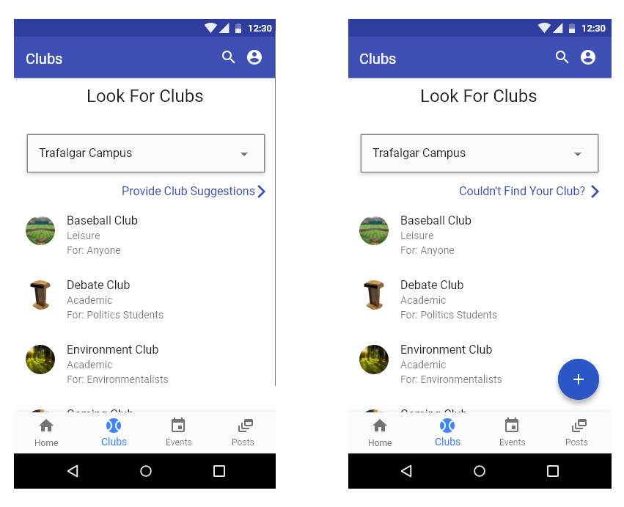
- Revised Club Search Screen [9] [17]
In addition, the event search screen was changed to add a plus button for adding an event [9] [17]. However, the user can only add an event when they are a club leader [9] [17]. The “Basketball Match” event was also changed to a “Sports Study Session” event [9] [17]. Fig. 16. demonstrates the event search screen before and after [9] [17].
Finally, the post search screen was modified to include a plus button [9] [17]. However, the user can only add a post when they have joined at least one club [9] [17]. Fig. 17. demonstrates the post search screen before and after [9] [17].
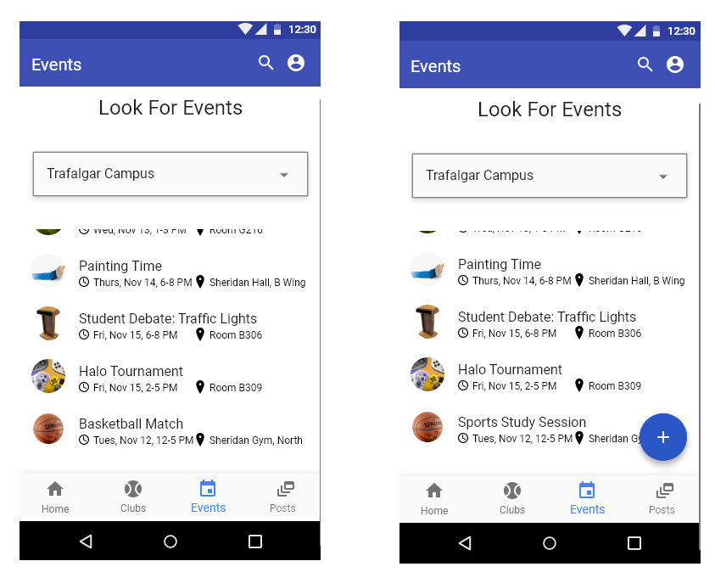
- Revised Event Search Screen [9] [17]
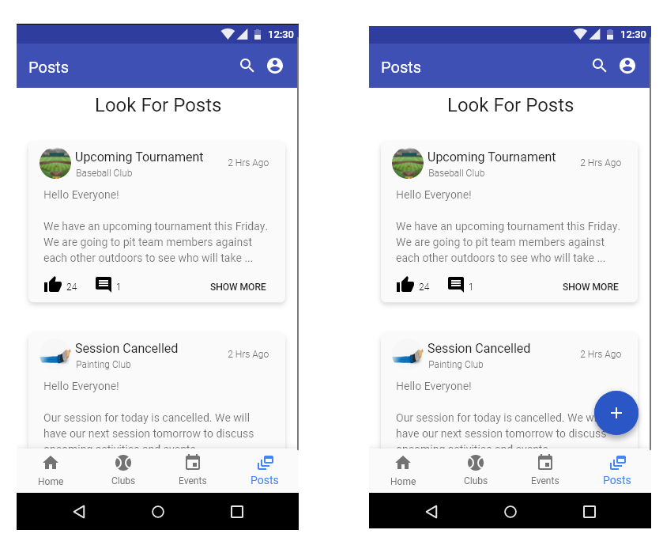
- Revised Post Search Screen [9] [17]

Future works & Conclusions
In conclusion, we have discussed the overall evolution of our Clubber application. This includes what the needs are for the college club market, the competitor applications in the market, the initial prototype of our application, a revised prototype of our application based on HCI concepts, a user testing experiment with the revised prototype, and a finalized prototype based on feedback from the revised prototype. Overall, the Clubber application prototype will be improved in the future by conducting a second user test with the new prototype. Finally, the Clubber application itself will be developed based on the prototype that was created.

References
- “BAND - App for all groups – Apps on Google Play,” Google. [Online]. Available: https://play.google.com/store/apps/details?id=com.nhn.android.band&hl=en_CA. [Accessed: 13-Dec-2019].
- “Gant - Groups and Teams – Apps on Google Play,” Google. [Online]. Available: https://play.google.com/store/apps/details?id=com.quiply.QuiplyAppDev&hl=en_CA. [Accessed: 13-Dec-2019].
- “North West College - Apps on Google Play,” Google. [Online]. Available: https://play.google.com/store/apps/details?id=com.oohlala.nwc&hl=en_US. [Accessed: 13-Dec-2019].
- “Lakeland College – Apps on Google Play,” Google. [Online]. Available: https://play.google.com/store/apps/details?id=com.lakeland&hl=en_CA. [Accessed: 13-Dec-2019].
- Lakeland College Canada (2019, Sept. 2). Lakeland App Tutorial [Video file]. Available: https://www.youtube.com/watch?v=HiaXy-egNzI
- G. R. E. Said, “The Intention to Use Mobile Student Portal: A Mobile Human Computer Interaction Study in a University Context in Egypt,” Mobile Information Systems, vol. 2018, pp. 1–8, 2018.
- “Clubs Corner,” Home. [Online]. Available: https://clubscorner.thessu.ca/campusvibe/campus/3d5704c1-0426-46ce-8e66-60f1dedf03ba/. [Accessed: 09-Oct-2019].
- “ClubRunner App,” ClubRunner. [Online]. Available: https://site.clubrunner.ca/page/clubrunner-mobile-app-now-available. [Accessed: 09-Oct-2019].
- N. Shaw, M. S. Shah, and V. Batirow, “NelsonShaw/HCI-Final-Report,” GitHub. [Online]. Available: https://github.com/NelsonShaw/HCI-Final-Report. [Accessed: 13-Dec-2019].
- N. Shaw, “HCIAssignment1,” Welcome to XD Ideas – Where Designers Go to Grow. [Online]. Available: https://xd.adobe.com/view/a09c2f70-474f-4b3c-43c5-41d1b7668811-d6ad/. [Accessed: 13-Dec-2019].
- V. Batirow, “Assignment1_HCI,” Welcome to XD Ideas – Where Designers Go to Grow. [Online]. Available: https://xd.adobe.com/view/4cd7aa52-0f2a-4fce-6b22-31e609d16d26-3ae6/. [Accessed: 13-Dec-2019].
- M. S. Shah, “HCI-Ass1,” Welcome to XD Ideas – Where Designers Go to Grow. [Online]. Available: https://xd.adobe.com/view/7ca823b8-1f0d-455b-6c93-f48fc52af414-0a99/. [Accessed: 13-Dec-2019].
- B. Xiaoxiao and L. Wenming, “Research on the application of color semantics in the human-computer interaction design of smartphones,” MATEC Web of Conferences, vol. 176, p. 04001, 2018.
- N. Shaw, M. S. Shah, and V. Batirow, “HCI Assignment 2 Iteration 2,” Welcome to XD Ideas – Where Designers Go to Grow. [Online]. Available: https://xd.adobe.com/view/fa3f8686-3d6a-4c16-45ea-adf578882dfd-8c0e/. [Accessed: 13-Dec-2019].
- T. S. Amer and T. L. Johnson, “IT Progress Indicators,” International Journal of Technology and Human Interaction, vol. 10, no. 3, pp. 58–71, 2014.
- S. J. Isherwood, S. J. P. Mcdougall, and M. B. Curry, “Icon Identification in Context: The Changing Role of Icon Characteristics With User Experience,” Human Factors: The Journal of the Human Factors and Ergonomics Society, vol. 49, no. 3, pp. 465–476, 2007.
- N. Shaw, “HCI Clubber Final Prototype,” Welcome to XD Ideas – Where Designers Go to Grow. [Online]. Available: https://xd.adobe.com/view/3fa21665-a58a-4d3c-49a6-8ad4f352e40b-4993/. [Accessed: 13-Dec-2019].

